

New Product News

Office of Materials Management

**Welcome to “New Product News”**

In an effort to keep you up-to-date on the new products being evaluated by the department, New Product News serves to highlight some ongoing and completed evaluations and resulting specification modifications. This document, as well as a list of approved materials can be found online at the [Office of Materials Management website](https://www.dot.state.oh.us/Divisions/ConstructionMgt/Materials/Pages/default.aspx).

Any comments/questions or have new product needs, please contact Brad Young [brad.young2@dot.ohio.gov](mailto:brad.young2@dot.ohio.gov) or 614-351-2882.

**2015 New Product Highlights**

Completed Evaluations

1. Non-tracking Tack Coat – This material now has a pay item under 407 and a material specification under 702.12 (Supplement 1128). Allowable products are listed on the Approved List. Three products are listed with multiple suppliers.
2. Asphalt Concrete with Fibers is covered under SS826. Three types of fibers are listed for use.
3. Hot-in-Place Recycling has been updated to include another manufacturer’s processes under SS822
4. Concrete Patching with Galvanic Anodes is now a generic specification and is covered under SS844. Three products are listed for use on the Approved List
5. Armorless Preformed Joint Seal – covered under Standard Drawing AS-2-15. Three products are listed as approved for use.



**Ongoing Evaluations**

The products listed below are currently installed and are under evaluation.

Milliken Concrete Cloth

Bridge erosion protection and culvert repair. Product comes in 3 foot wide rolls, various thickness. Rolled into place, saturated with water and the product hardens. The Office of Hydraulics is looking for a site to evaluate the product to repair deteriorated inverts of metal culverts. The photo below is of a bridge erosion protection demo done on OTT-579-1.85 – Installed by county forces 10/2015.

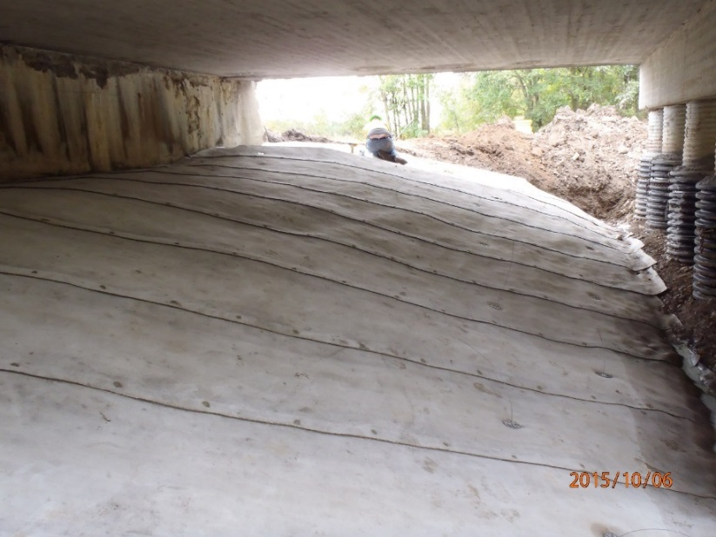

American Molded Plastics

Tall, guardrail delineator attached to a spring. Designed to withstand force of plowed snow and also remain visible when snow piles up over guardrail. Product is on term contract 126-16 but is not yet covered by specification.

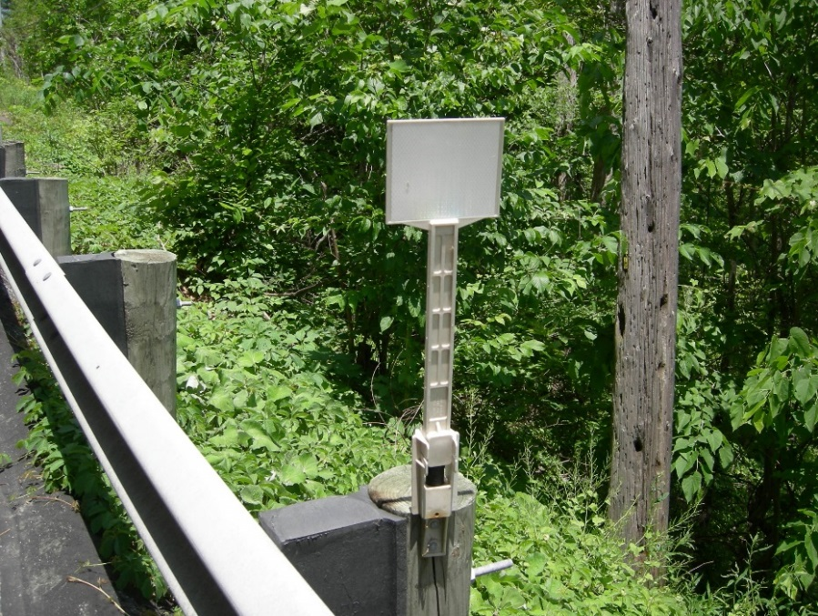

Trinity Highway Products

GuideLite – Plastic RPM with metal rails. Product is currently being evaluated on I-70 just west of Columbus. Product is promoted as a lightweight alternative to cast iron RPM’s.

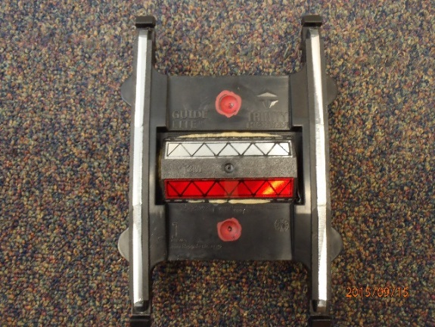

Tybeca Shield

PolySalt Armor – Plastic pier cover. Product is being evaluated in three districts. A possible research project may be funded to evaluate the cost effectiveness of not only this product but other techniques to protect bridge piers in the snow/salt splash zone.

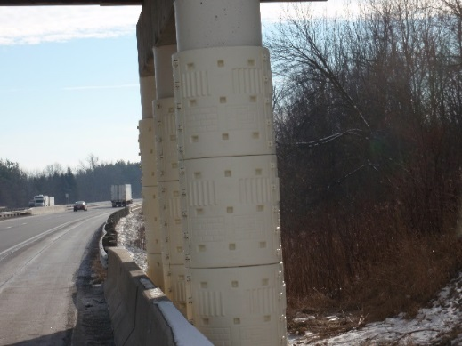

High Friction Surface Treatment

Durable bauxite aggregate embedded in epoxy overlay. Product used in areas where a high friction surface is required. A generic specification is being drafted that incorporates several manufacturers’ products and includes material and application requirements.

Road High Friction Surface Treatment


**Listing of other products submitted in 2015**

The products listed below are currently in some phase of development. For more information on these products, contact Brad Young [brad.young2@dot.ohio.gov](mailto:brad.young2@dot.ohio.gov) or 614-351-2882.

|  |  |  |
| --- | --- | --- |
| **MANUFACTURER** | **PRODUCT NAME** | **DESCRIPTION** |
| Advanced Aramid Fibers | ACE Fiber Surface Tech | reinforce AC pavement |
| A-Lok Products Inc | various pipe products | various pipe products |
| American Molded Plastics | AMP-100-CR | cable rail delineator |
| American Molded Plastics | AMP-701-44OH | guardrail reflector (reinforced to withstand plowed snow) |
| Applied Polymer Systems | Silt Stop Powder | anionic polyacrylamide erosion control flocculent |
| Arizona Chemical Company | SylvaRoad RP1000 | rejuvenator for high RAP mixes |
| Armacell | ArmaBlok | foam bridge expansion joint |
| CCL Design | Stoneshield | urethane coating for bridges |
| Contech | CON/SPAN i – Series | designed to help reestablish a natural stream channel bottom |
| EBAA Iron Inc / Riehl Systems | Megalug | mechanical pipe joint restraint |
| Engineering Research Associates | TK200 | noise wall concrete sealer |
| Enssolutions Inc | TOP | tar oil pitch-aggregate shoulder stabilization |
| EnviRoad LLC | Earthbind 100 | dust control |
| EnviRoad LLC | Earthbind Stabilizer Rejuvenating Agent (EBS-RA) | cold paving using reclaimed asphalt |
| EnviRoad LLC / Global Stabilization LLC | Earthbind Stabilizer | soil stabilization chemical |
| Environmental Energy Solutions | UltraBond | dust control |
| Enviroseal Corp | MV55, M10+50, or MA60 | soil stabilization chemical |
| Filtrexx International | Filtrexx DiversionSoxx | diversion or redirection of runoff |
| Gain Engineering | EDS-6D Biodegradable Stake | erosion control mat stake |
| Garland Co | Various carbon fiber products | carbon fiber wrap and asphalt pavement reinforcement |
| GM Boston Company | PX300 | soil stabilization chemical |
| IMRAE Corp | CM7007 CoatMasters | acrylic and bituminous hybrid polymeric emulsion |
| Innovative Turf Solutions | Hydrobond/FI-1045 | tackifier, dust control, soil stabilizer, flocculent |
| Innovative Turf Solutions | PAM tablets | flocculent |
| International Zinc Association | CGR | galvanized rebar |
| Kurtz Bros | Diamond Sock | compost filter sock |
| Magna Intl Inc | Not determined yet | concrete admixture-inorganic oxides and carbon nano-platelets |
| Mapei Americas | Planitop 12 SR | concrete repair-horizontal, vertical, overhead |
| Nomaco | Nomaflex | semi-rigid, closed-cell, polypropylene foam, preformed expansion joint filler material |
| Reline America | Alphaliner 500 | CIPP pipe rehabilitation using UV light to cure |
| SafeTspin | RA-100 | wind/traffic causes 3 sided reflective device to spin |
| Schenk Industrial Marketing Inc | Not determined yet | hollow steel tube dowel bar |
| Schul International | Sealtite 50N | bridge expansion joint precompressed foam |
| SwiftGate | SwiftGate | automatic lane closure system |
| Tapco | BlinkerRadar | solar powered vehicle speed limit on signs |
| Tapco | BlinkerPaddle LED Enhanced Paddle | LED enhanced stop/slow paddle |
| Tapco | V-loc | break away sign support system |
| Terra Nova | EarthGuard, Fiber Matrix, Edge, and Fusion | slope erosion protection |
| Trinity Highway | QuadGuard Elite M10 | redirective, non-gating crash cushion |
| Trinity Highway Products | RumbleTough | temporary Rumble Strip |

This document, as well as a list of approved materials can be found online at the [Office of Materials Management website](https://www.dot.state.oh.us/Divisions/ConstructionMgt/Materials/Pages/default.aspx).

Remember, if you have any comments/questions or have new product needs, please contact Brad Young [brad.young2@dot.ohio.gov](mailto:brad.young2@dot.ohio.gov) or 614-351-2882.

